 | 

AI vs Human Teaching: What Do Students Prefer?

Course: Applications of Information and Communication Technology Lab
Instructor: Ms. Ramsha Khalid
Group Members:
- Maham Zafar (Roll no. 182)
- Muhammad Ahmed Chaudhry (Roll no. 184)
- Nabeeha Shoaib (Roll no. 190)
- Isma Wasif (Roll no. 226)
- Anfaal Abbas (Roll no. 233)
Semester/Section:
- First Semester (Fall 2025)
- Section D

Table of Contents
- Introduction
- Data Summary & Observations
- Findings & Discussion
- Conclusion & Suggestions

- Introduction:
Artificial Intelligence (AI) in last few years has become an influential tool in education. Students today can access many AI platforms, for example, ChatGPT, Claude AI, Gemini, Grok etc as well as AI-based learning platforms of many educational institutions. These platforms can provide feedback, lessons, and most importantly they are available all the time. But, whatever benefits AI provides us, the importance of human teachers remains as they offer sympathy, motivation, and real-time interaction.
This study aims to find if students prefer between AI-based teaching or human teaching methods, and to understand whether AI can replace or change the role of educators in modern learning.

- Data Summary and Observations:
The collected data was analyzed to draw a comparison between student’s views on AI-based and human based teaching. Key insights from the data collected through survey are shown below and supported by visual graphics.
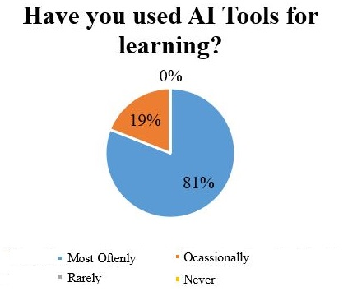

Figure 2.1: 81% of the respondents confirmed that they have used AI for learning purposes.

This shows that students are interacting with AI mostly for learning purposes.

Figure 2.2: Average Effectiveness Rating (AI vs Human Teaching)
Students rated AI based learning slightly higher (average rating 3.81/5) than human teaching (average rating 3.76/5).

This indicate that while human teaching is viewed as effective for understanding complex concepts, AI is getting appreciated due to its convenience and accessibility.

Figure 2.3: Students’ Preferred Teaching Method

Of the 21 responses received, 40% respondents preferred a balanced combination of both AI and human teaching, 36% favored human teachers & 24% preferred AI-based learning.
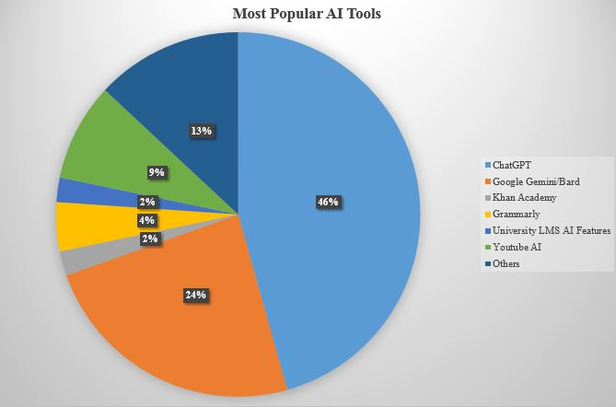
Figure 2.4: Most Popular AI Tools
In the survey, ChatGPT was found to be most popular among the available AI tools for teaching.

- Findings and Discussions:
Perceived Effectiveness:
Students were asked to rate the effectiveness of human teachers and AI-based tools on a scale of 1 to 5, with 5 depicting highly effective. The difference found after taking the mean of overall rating responses is found to be marginal, showing a slight favor toward AI.

Metric | Average Rating (1 - 5) | Maximum Percentage
AI Tools | 3.81 | 76.19%
Human Teachers | 3.76 | 75.23%

Preference for Complex Concepts:
Despite the near similar ratings in teaching effectiveness, majority of students were found to be leaning toward human instruction when faced with understanding difficult subjects or concepts.

Learning Preference | Count (N=21) | Percentage
Strongly prefer Human | 5 | 24%
Somewhat prefer Human | 7 | 33%
No preference | 4 | 19%
Somewhat prefer AI | 4 | 19%
Strongly prefer AI | 1 | 5%

This suggests that while AI is recognized as a highly effective resource, human teachers are still perceived as indispensable for deeper understanding or complex problem-solving.

Strengths of Human Teachers:
The frequently cited strengths of human teachers highlight their uniqueness:
- Personal connection and empathy.
- Provides motivation and encouragement.
- Better at explaining complex concepts.
- Classroom interaction and discussions.

- Conclusion and Suggestions:
Conclusion:
The collected data show that AI tools have achieved high acceptance among students as respondents rated their effectiveness slightly higher than human instructors. However, human teachers still retain an important role in the learning process, especially for understanding complex problems, emotional support, and fostering interactive discussions. The data shows that the students envision a hybrid future involving both human teaching and AI-based learning.
Suggestions:
- Focus AI Integration: Utilize AI tools to handle administrative tasks, provide personalized feedbacks, and deliver supplemental practices (the "50% AI" component).
- Amplify Human-Centric Skills: Invest in professional development of faculties, so they can enhance their skills in areas that AI cannot replicate like empathy, motivational coaching, facilitating complex conceptual debates, and dynamic classroom interaction.
- Develop Blended Curriculum: Prepare curriculum models that clearly designate which parts of the course can be best served by AI (e.g., self-paced review, information retrieval etc) and which parts of the course require human intervention (e.g., critical thinking, real-world application, ethical discussions etc).

- Summary:
In summary, the survey findings show that both AI and human teaching methods have their own importance. AI can provide instant information and personalized learning experiences, but it lacks values for empathy and adaptability, values which human teachers can provide.
It is recommended that educational institutions shall integrate AI tools as assistants to teachers, not replacements, to support them and enrich the learning process. This balanced approach can better prepare students for technology-driven futures as well as preserving human mentorship.

